Image analysis second assignment report

Date:2019-03-12

1. Identification of person and assignment:

* Group member:

Yukuan Hao, Liming Yang, Liang Gu, Rouwen Mao

* Assignment:

1. Enhance the image

1. Histogram stretching

2. Power law transform

3. Linear (Gaussian and average mask) and non-linear filtering (Median filter)

B. Edge detection

Detect edge and generate the magnitude of gradient (Sobel mask)

1. Brief problems definition:

Writing C++ functions to enhance the image, and find the best solution to improve and detect the edges of image MRI.pgm.

1. Summary of the solution:

Our group write six functions to enhance and extract edges from the image, then we test these six methods, compare the results, and combine different methods to process the image, and finally get the best solution.

1. Result

First, we found that the target image has low contrast, and from the histogram of the target image, we found the pixel value are gathered in small number, so we can process the image by histogram stretch or power law filter. After our test, we found a solution which can get a good contrast image. Here is the solution:

* 1. histogram stretch
  2. power law transform (c=1,gamma=1.2)

Here are the result:

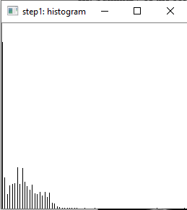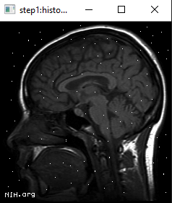

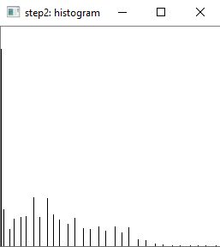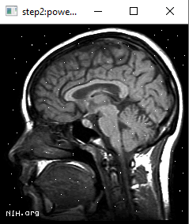

Howerver,there are white noises in the target image. In order to eliminate these white noises, we use the median filter to process the image. Our median function needs user define the size of the mask,through our test, choose 3x3 mask can get the best results.There are the results.

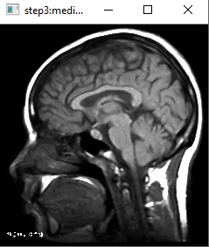 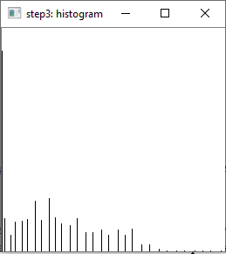

At last, we using sobel edge detection method get the image edge, here is the result

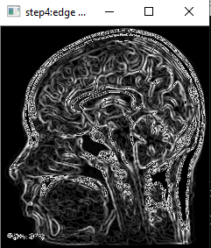

The result is not good, after our test, we found a good way to detect object edge, we only need to use median filter and detect the edge, then using power law transform(c=0.7,gamma=1.4) to enhance the result. Here is the result.

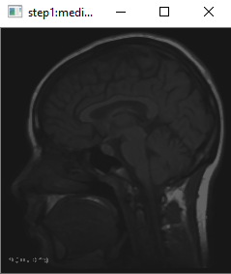 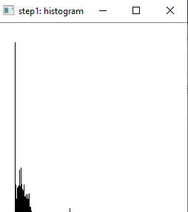

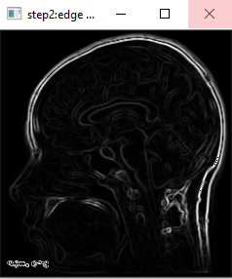 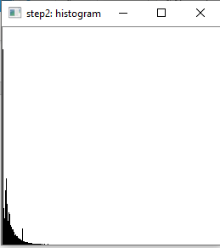

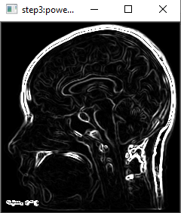 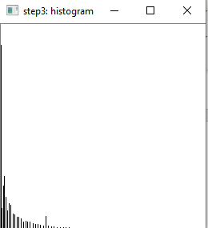

1. discussion

In this assignment, our group write a C++ program which contain 6 methods to enhance image and detect the edge of image, at the same time, the program provide the interactive with users, they can choose which method they need and the result would show at once.

In image enhance part, we try different combination from 6 methods, then we got a best solution. Because the target image contain white noises, we can use median ,Gaussian, and average mask to process the image, to avoid blur the edge,we choose median filter to process the image, the result show that the white noises are disappeared, however, from the histogram of image, we found the pixel value are gathered in small value area, so we use histogram stretch method to increase the image contrast, but the image still dark. Then we can stretch the small value area, so we choose power law transform.

In edge detection section, originally we want to process the result in image enhance part, but we got a bad result, so we choose another way to get the edge. After our test, we found that we can get a good edge when we only do median filter to enhance the image, so we believe the histogram stretch and power law transform methods increase the pixel difference, and adding difficulty to extracting edges. Then, we decide enhance the image after extract edges, from the image histogram we know the power law transform method can give us a better result, so we choose that method.

As a result, after image enhance process, we got a good contrast image without noises, and we also get a clear edge after edge detection process.

From this assignment, we review the computer vision knowledge, and also practice the c++ programming ability, we learned how to use the histogram to determine which method to use next.